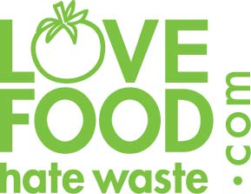 | 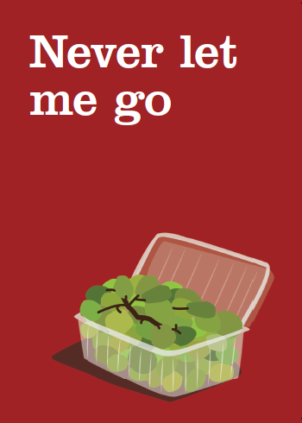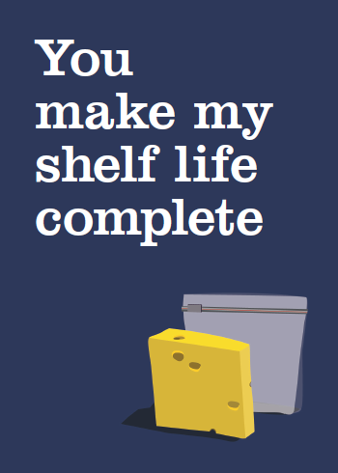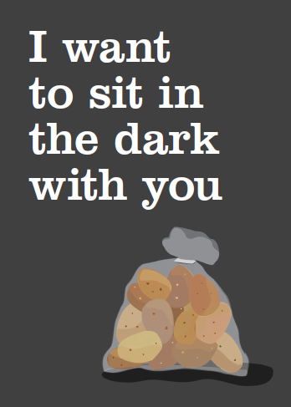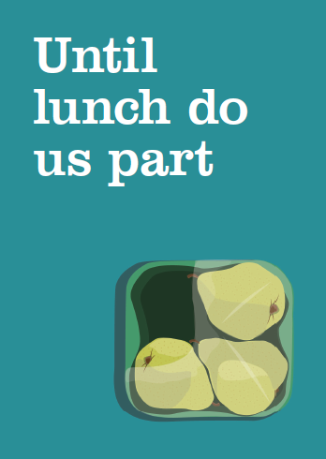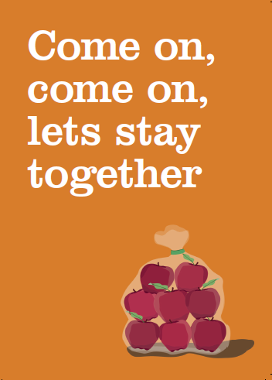
Fresher for Longer – key messages
Top 5 key messages:
- Love Food Hate Waste is today launching ‘Fresher for Longer in partnership with Marks and Spencer in their Tunbridge Wells store in Kent to show how packaging not only protects our food from damage, but keeps it fresher for longer in our homes too, meaning less is wasted and we save more

- Only 13% of the public realise that packaging can play an important role in protecting food in the home.
Food loves the packaging it comes in as there’s nothing better to protect it and keep it fresher for longer. From ziplocks on cheese packs to breathable fruit and veg bags, packaging has been perfectly designed with all sorts of cunning features. So when you get your food home, keep it in its original packaging and follow instructions on the pack to keep food at its best

- Throwing away food as a result of it being not used in time is costing us, as consumers, £6.7 billion a year (£270 for the average household). With the majority of us (61%) believing that keeping fresh fruit and vegetables in their original packaging makes them ‘sweat’ and go off quicker, whereas the opposite is true, it’s easy to see why

- The impact on the environment of throwing away an apple is 6 times greater than the pack it comes in

- For tips on the best way to store your food go to lovefoodhatewaste.com

Top stats/tweets
- Only 13% of consumers realise that packaging can play an important role in protecting food in the home.
- 61% of us believe that keeping fresh fruit and vegetables in their original packaging makes them ‘sweat’ and go off quicker, whereas the opposite is true
- The impact on the environment of throwing away an apple is 6 times greater than the pack it comes in.
- The impact on the environment of throwing away tomatoes is 30 times greater than the pack they come in.
- The impact on the environment of throwing away lettuce is 100 times greater than the pack it comes in.
- Most fresh fruit & veg will last up to 2 weeks longer if kept in the fridge in their original pack.
- In the UK we buy almost 40 million tonnes of food & drink every year, and this is protected by less than 4 million tonnes of packaging.
- Shrink-wrapped cucumbers will last around three times longer than non-shrink-wrapped ones.

